Receiver Operator Characteristic (ROC) curves are commonly used when binary decision problems are evaluated. In a ROC curve the relation between the true positive rate (TPR) and the false positive rate (FPR) is shown. These are also measures for the sensitivity and specificity respectively. The TPR and FPR are defined as:

$$TPR=\frac{TP}{TP+FN}$$

$$FPR=\frac{FP}{FP+TN}$$

With TP the true positives, FN the false negatives, FP the false positives and TN the true negatives. 1 AUC is the area under the ROC curve and it represents the probability of correct ranking. Thus, when the AUC is near to 1 it implies an excellent model with great classification. However, when this value is near to 0 the model incorrectly classifies the input. 2

A convolutional neural network model is trained on the dataset of the patchCAMELYON challenge in order to detect metastases. To evaluate the model a ROC curve is plotted and the AUC is determined after the model is trained. The train model is saved, so that the evaluation can also be done without training the model. The model is evaluated using the validation set, as there is no access to the ground truth of the test set. The results can be seen in figure 1.

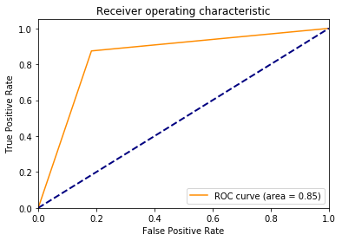

Figure ROC curve and AUC

[1] Davis, J., & Goadrich, M. (n.d.). *The Relationship Between Precision-Recall and ROC Curves*. Retrieved from https://www.biostat.wisc.edu/~page/rocpr.pdf

[2] Hanley, J. A., & McNeil, B. J. (n.d.). *The Meaning and Use of the Area under a Receiver Operating Characteristic (ROC) Curve1*. Retrieved from https://pubs.rsna.org/doi/pdf/10.1148/radiology.143.1.7063747